**Initial Proposal**

**GEOG 4043**

Jordan, McClain, Jason, Jeremy

**26 OCT 2021**

We propose to create an interactive geovisualization[webmap] that uses a6-month snapshot sequential temporal scale. We plan to provide visuals that show bus stop frequency before and during the COVID-19 pandemic. Our data set will start in 2018 going through to 2020. The visual will include how the frequency of routes changed from 2018-2020 and its effect on socio-economic data. The graphic will allow the user to see the RTD bus frequency during the pandemic. Our main plan is to tie the bus frequency to socioeconomic factors (such as job density) or allow the user to visualize bus stops and routes that have decreased in frequency. With this tool, it will allow the user to easily visualize the effects of the pandemic and public transportation via spatiotemporal elements.This visualization will allow the user to query different years, routes, and different variables associated with public transportation and socioeconomic factors. Using a simple three-panel layout, we will have the main map on the top left, the query tool on the top right, and on the bottom center, we will have a visualization of the data from the routes and their frequency, in which you can easily pick certain routes and view them on the map (figure 1 below). Our visualization technique for the data is to be determined, but there are numerous articles below that introduce different methods for visualizing public transportation data.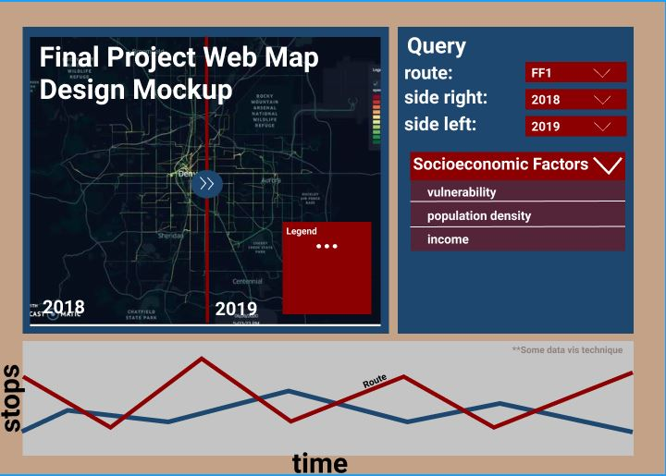

**Design mockups:**

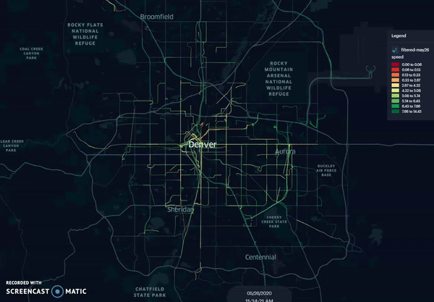

Kurkcu, A. (2021, June 17). *Visualizing Bus Trajectories in Denver*. Medium.<https://towardsdatascience.com/visualizing-bus-trajectories-in-denver-85ff02f3a746>

***BIBLIOGRAPHY***

* Kopsidas, A., Milioti, C., Kepaptsoglou, K., & Vlachogianni, E. I. (2021). How did the COVID-19 pandemic impact traveler behavior toward public transport? The case of Athens, Greece. Transportation Letters, 13(5–6), 344–352.<https://doi.org/10.1080/19427867.2021.1901029>
  + COVID-19 led to significant changes in commutes of various individuals as lockdowns or shutdowns were imposed. The paper focuses on the recovery post-pandemic but provides insight into how various models were used to determine the return pre-pandemic levels. This doesn't directly apply, but the processes they use to handle data may provide insight or means for our group to do the same on pre-pandemic data. The paper also highlights a weak return hypothesis (psychological factors and the like- which would also be applicable to the start of the pandemic and during). The paper also discusses private car use (such as increase in purchases during the pandemic- which also has some bearing on our data).
* Koutsopoulos, H. N., Ma, Z., Noursalehi, P., & Zhu, Y. (2019). Chapter 10—Transit Data Analytics for Planning, Monitoring, Control, and Information. In C. Antoniou, L. Dimitriou, & F. Pereira (Eds.), Mobility Patterns, Big Data and Transport Analytics (pp. 229–261). Elsevier. <https://doi.org/10.1016/B978-0-12-812970-8.00010-5>
  + Automatically collected data can be used by transit industries to better understand patterns. This data can be used for planning, performance measurements, operations control and management, and customer information. The article focuses on system performance from customers pov, real-time improvements, and strategies to mitigate over/under crowding. The last part on mitigating over/under crowding relates to our project. Transit industries look at automatically-collected passenger count to change route frequencies.
* Nguyen, H. T., Duong, C. K. T., Bui, T. T., & Tran, P. V. (2012). Visualization of Spatio-temporal Data of Bus Trips. *2012 International Conference on Control, Automation and Information Sciences (Iccais)*, 392–397.<https://www.webofscience.com/wos/woscc/full-record/WOS:000320314100070>
  + Buses are a public and generally accessible means to travel in larger urban settings. Using web-based interactive maps & models enable visualisation techniques that traditional paper maps simply do not provide or match. Traditional maps provide static data/images and are useful in identifying locations to access public transit. They however often lack any temporal data (such as busy or light use periods). This paper highlights these shortcomings and provides an analysis of why web tools (interactive) are superior. The paper emphasizes the use of Spatio-temporal data of bus trips on temporal maps, users can mark out various routes for their more appropriate travels. This article implemented visualization tools for the design of bus travels on temporal maps.
* Pang, J., Tian, C., Huang, Y., Buckles, B., & Mirzaei, A. (2017). Atvis: A New Transit Visualization System. In D. A. Griffith, Y. Chun, & D. J. Dean (Eds.), *Advances in Geocomputation* (pp. 85–96). Springer International Publishing.<https://doi.org/10.1007/978-3-319-22786-3_9>
  + This paper discusses a specific system used to more efficiently visualize spatial and temporal transit data. This system compares traditional mapping and presentation tools to “Atvis”. Atvis focuses more on ridership, visualizing traffic data at or between stops, and inter-stop relationships, disregarding information that may not be essential to a user. The tool may not specifically apply to our web map, however would provide possible insight into how a similar web map could be generated and displayed. The system focuses on similar datasets as the web map being made.
* Prommaharaj, P., Phithakkitnukoon, S., Demissie, M. G., Kattan, L., & Ratti, C. (2020). Visualizing public transit system operation with GTFS data: A case study of Calgary, Canada. *Heliyon*, *6*(4), e03729.<https://doi.org/10.1016/j.heliyon.2020.e03729>
  + This paper discusses the General Transit Feed Specification (GTFS). Outlining this dataset that agencies generate and share openly with the public. These GTFS feeds contain data for scheduled transit service including stop and route locations and schedules information. This paper discusses how to demonstrate the potential of GTFS data, specifically, specifically describing GTFS data visualization tools that display both spatial and temporal data from transit services allowing user insights can be had. Our web map project uses GTFS data collected from Denver RTD, and may provide some insight into how tools can be made/used to generate interactive displays.
* *Open Spatial Data*. (n.d.). RTD - Denver. Retrieved October 26, 2021, from<https://www.rtd-denver.com/business-center/open-spatial-data>